Scatter Graph Worksheet

For each of the graphs below; a) describe the type of correlation the graph shows,

b) what the practical interpretation of this is and

c) draw a line of best fit.

1. Below is a table and incomplete scatter graph investigating the value of nine Volkswagen Golf cars. Plot the last three points from the table.

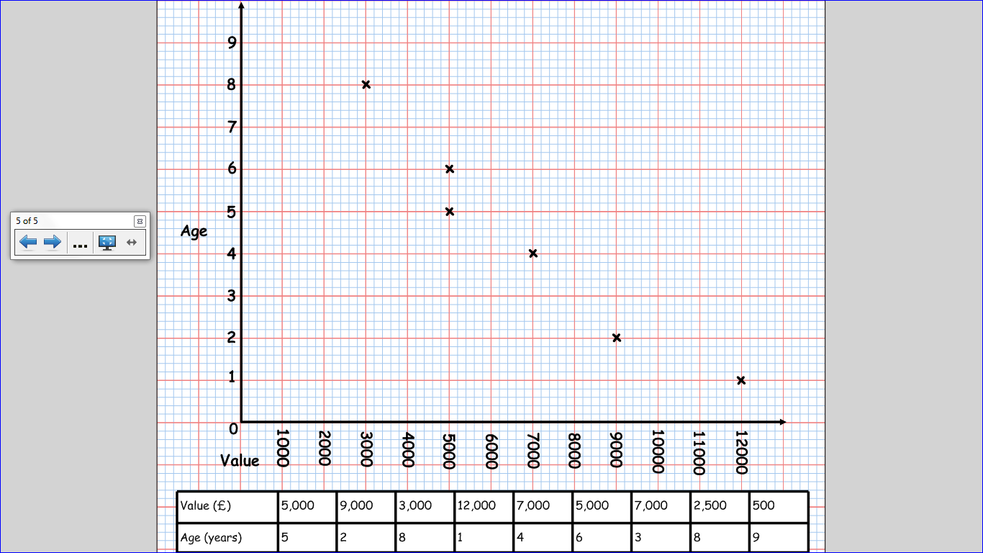

b)

a)



1. Here is a scatter graph showing the results in a science test and in a maths test for some pupils. Plot the last three pupils’ results on the graph.

|  |  |
| --- | --- |
| Science | Maths |
| 44 | 43 |
| 24 | 28 |
| 40 | 38 |
| 48 | 42 |
| 30 | 32 |
| 25 | 30 |
| 10 | 25 |
| 37 | 35 |
| 34 | 37 |
| 38 | 40 |

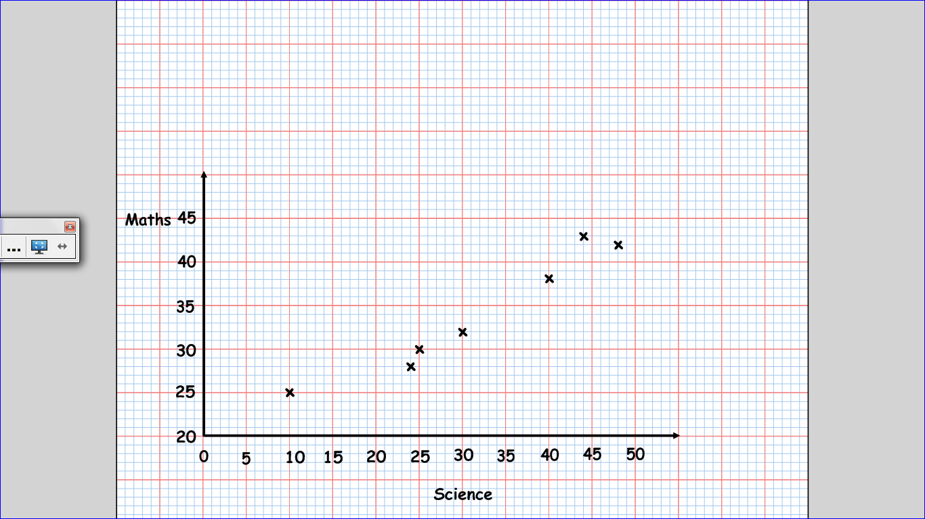

b)

a)

|  |  |
| --- | --- |
| Goals | Points |
| 103 | 86 |
| 86 | 85 |
| 83 | 75 |
| 67 | 70 |
| 73 | 67 |
| 52 | 64 |
| 61 | 63 |
| 60 | 61 |
| 38 | 50 |
| 41 | 50 |

1. The table below shows the number of goals scored and number of points gained for the top ten Premier League teams last season. Plot the last FOUR points to complete the scatter graph.

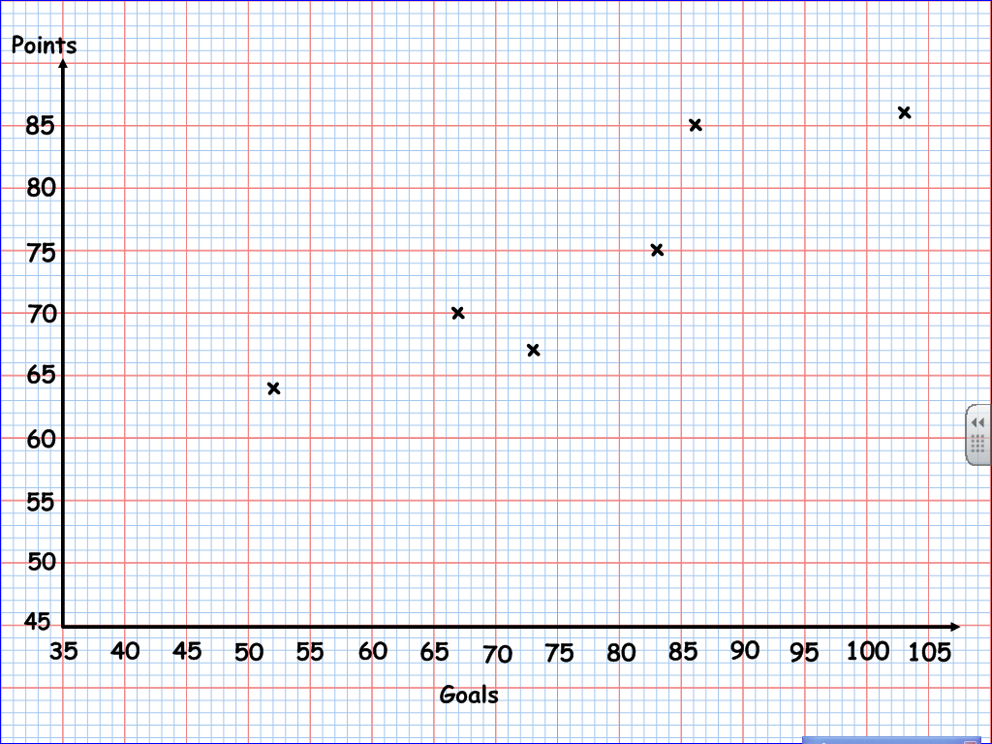

a)

b)

1. Here is a table showing the shoe sizes and ages of the teachers in the maths department. Plot the points on the graph.

|  |  |
| --- | --- |
| Age | Shoe size |
| 31 | 11 |
| 26 | 8 |
| 53 | 12 |
| 45 | 10 |
| 50 | 6 |
| 38 | 7 |
| 28 | 5 |
| 34 | 6 |
| 30 | 10 |

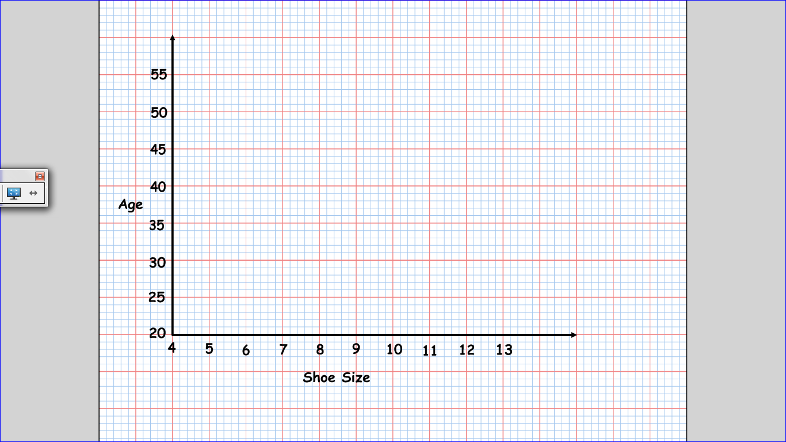

b)

a)